Sri Sivasubramaniya Nadar College of Engineering
(An Autonomous Institution, Affiliated to Anna University)

PROJECT REPORT

EduNext: Attention & Emotion-Aware Course Curation for Self-Paced Learners


Submitted by:

Daniel Wilson IT - A | 3122245002013
Midhush Kanna VG IT - A | 3122245002051

[Guides Signature]
Guided By:

Dr. S. Mohanavalli
Associate Professor
Department of Information Technology
Academic Year: 2026–2027

TABLE OF CONTENTS

S. No. | Contents | Page No.
1 | ABSTRACT | 1
2 | INTRODUCTION | 2
3 | LITERATURE SURVEY / PATENT SEARCH (if any) | 3
4 | RESEARCH GAP AND PROBLEM STATEMENT | 6
5 | NOVELTY/INNOVATION | 7
6 | PROPOSED METHODOLOGY | 8
7 | MARKET VALUE ANALYSIS | 13
8 | UNIQUE SELLING POINT | 14
9 | RESULTS AND DISCUSSION | 15
10 | REFERENCES | 19

1. ABSTRACT
EduNext is a self-hosted, web-based course platform that personalises online learning by estimating a learner's attention and emotional state in real time, entirely on the learner's own device. Using only a standard webcam, the system measures spontaneous eye-blink rate with Google MediaPipe FaceMesh and recognises facial expressions with a lightweight in-browser neural network, then fuses these signals with quick self-reported feedback into a single engagement score (0-100). Because people blink at very different rates, EduNext first builds a short, private calibration baseline for each learner, so attention is judged relative to that individual rather than a fixed average. During a lesson the platform reads engagement every few seconds and adapts the experience - slowing down, replaying a section, suggesting a short break, or switching a lesson between a visual and a hands-on presentation - always under the learner's control. A core design invariant is privacy: camera frames never leave the browser; only derived numbers and labels are stored, and an automated test enforces that the uploaded data contains no image content. The system was implemented as a full-stack application (React front end, Express/SQLite back end, a shared formula library) and deployed publicly. This report describes the motivation, related work, methodology, novelty, market potential and results of the project, which demonstrates a working, privacy-respecting, adaptive learning prototype that requires no special hardware beyond a webcam.
2. INTRODUCTION
Online and self-paced learning has expanded rapidly, but it has lost a feedback channel that a good classroom teacher relies on constantly: the ability to see when a learner is engaged, confused, or tired, and to adapt accordingly. A video lecture plays at the same pace whether the viewer is fully focused or half asleep. The result is wasted study time, frustration, and poor retention.
EduNext addresses this gap by giving an online course the ability to 'pay attention back'. It estimates the learner's focus from two on-device signals - eye-blink rate and facial expression - and from short, optional feedback, and uses that estimate to adapt the lesson. Blink rate is a well-studied, low-cost proxy for attentional and cognitive state, and facial expression adds an emotional dimension (for example boredom or confusion). Crucially, all sensing runs inside the browser using the learner's own webcam; no video is ever uploaded, which removes the central privacy objection to attention-aware systems.
The main objectives of the project are:
1. To build a personal, per-learner blink baseline through a short calibration, so attention is measured relative to the individual, not an average.
2. To estimate live engagement during lessons by fusing blink rate, facial emotion and learner feedback into a single, smoothed score.
3. To adapt the lesson in real time (pace, replay, break, visual/hands-on format) based on that score, while keeping the learner in control.
4. To guarantee privacy by performing all sensing on-device and never transmitting images.
5. To implement and deploy a complete, usable web application demonstrating the above.

3. LITERATURE SURVEY / PATENT SEARCH
The project draws on three established research areas - blink behaviour and attention, facial-expression based emotion recognition, and adaptive/engagement-aware learning - together with widely used open-source computer-vision tooling.
Area / Work | Relevance to EduNext
Nakano et al. - eye-blink timing and attentional engagement | Evidence that spontaneous blink timing is tied to attentional state; supports blink rate as an attention proxy.
Ranti et al. - blink rate and cognitive load | Blink rate varies with mental effort and engagement; informs the mapping from blink rate to 'zones'.
Maffei & Angrilli - spontaneous eye-blink and emotional state | Blink behaviour is modulated by affect, motivating a multi-signal (blink + emotion) approach.
Ekman & Friesen - basic facial expressions of emotion | Foundation for the seven-class expression model used by the in-browser emotion network.
Csikszentmihalyi - Flow theory | Framing for sustained engagement and why adapting difficulty/pace matters.
MediaPipe FaceMesh (Google) | Real-time 468-point face landmarking used to compute the Eye Aspect Ratio for blink detection.
face-api.js / FaceExpressionNet | Lightweight browser-side expression recognition used for the emotion signal.

Patent / product search: commercial 'attention tracking' and proctoring tools exist, but they typically stream video or rely on server-side processing and dedicated eye-tracking hardware, raising privacy and cost concerns. EduNext's combination - fully on-device sensing, a personalised blink baseline, transparent and non-punitive adaptation - was not found as a single packaged offering, and the implementation uses only permissively licensed open-source components, so no patent conflict was identified for this academic prototype.

4. RESEARCH GAP AND PROBLEM STATEMENT
Existing e-learning platforms largely ignore real-time attention. The systems that do sense attention tend to fall into one of three gaps:
• Privacy: many upload webcam video or run inference in the cloud, which learners (and institutions) are rightly uncomfortable with, especially for minors.
• Personalisation: tools that use blink or gaze often apply a fixed threshold, ignoring that baseline blink rate varies widely between individuals and with lighting, screens and fatigue.
• Actionability and trust: attention is often merely logged (or used punitively, as in proctoring) rather than used transparently to help the learner, and the signals are presented as fact rather than estimate.
Problem statement:
Design and build a learning platform that estimates a learner's engagement in real time using only on-device webcam signals, personalises that estimate to the individual through a short calibration, and uses it to adapt the lesson helpfully and transparently - all without any image or video leaving the browser, and without special hardware.

5. NOVELTY / INNOVATION
• Fully on-device sensing: blink detection (MediaPipe FaceMesh + Eye Aspect Ratio) and emotion recognition (in-browser neural network) run in the browser; only derived numbers are ever stored, enforced by an automated privacy test.
• Personalised blink baseline: a short calibration measures the learner's own engaged vs. resting blink rates and rescales the attention zones to them, falling back to sensible defaults when the reads are too close or a camera is unavailable.
• Multi-signal fusion: a single engagement score combines blink rate (0.45), facial emotion (0.35) and learner feedback (0.20), re-weighted automatically when a signal is missing, and smoothed over time.
• Transparent, non-punitive adaptation: a deterministic curation engine suggests breaks, replays, pace changes or a visual/hands-on switch, each with a plain-language reason, and every action is the learner's choice.
• Learning-style detection: a short visual-vs-hands-on probe, refined over lessons, serves each lesson in the format the learner engages with more (with a small exploration rate to avoid lock-in).
• Honesty by design: the UI and data consistently frame outputs as estimates, not diagnoses, and a scripted demonstration mode is clearly labelled as a simulation.

6. PROPOSED METHODOLOGY
6.1 System Architecture
EduNext is a single-page web application backed by a small REST API. It is organised as a three-part monorepo so that the attention/engagement formulas live in exactly one place and are shared by both the browser and the server (no duplicated logic):
• shared - a pure, framework-free library holding every tunable constant and all the mathematics (blink zones, emotion grouping, tick building, engagement scoring, curation state machine, learning-style detection, course recommendation) with unit tests.
• backend - an Express server with a SQLite database (better-sqlite3), JWT authentication, and routes for accounts, profile/calibration, courses, lessons, sessions and insights.
• frontend - a React (Vite) application with a single persistent tracking provider that owns the camera and sensing pipeline, the lesson player, and the adaptive UI.

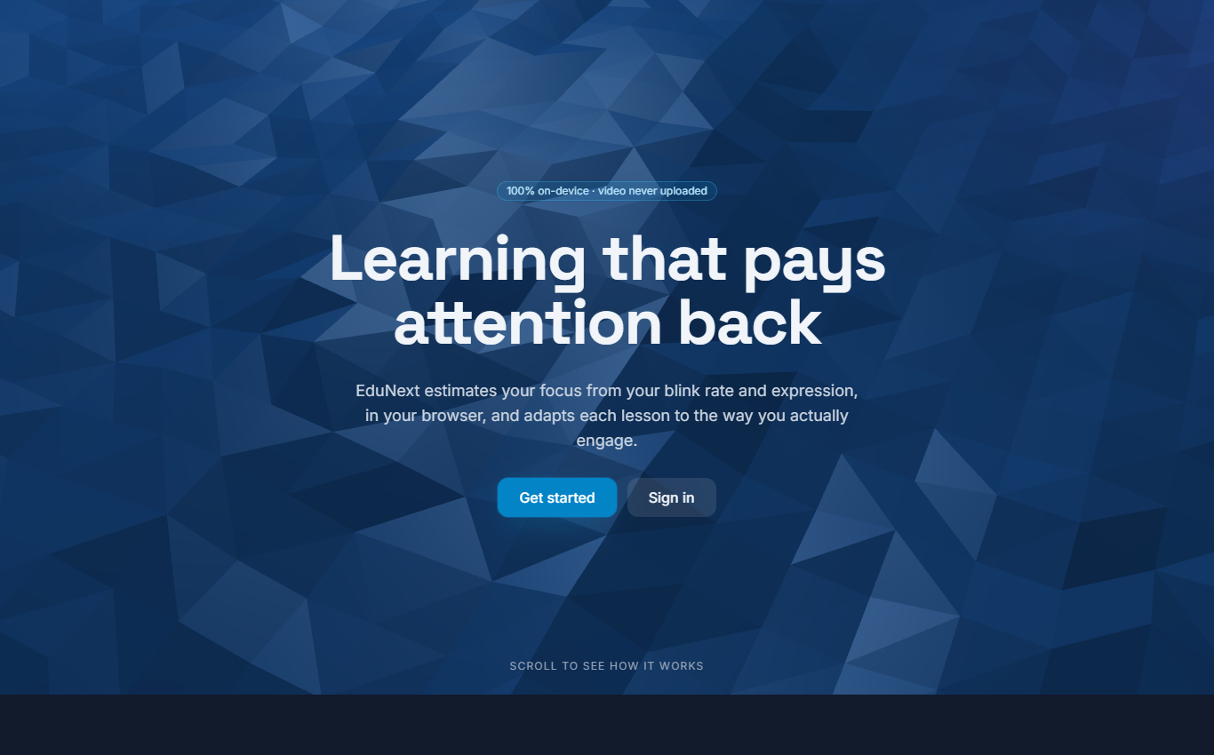
Figure 1: EduNext landing page.
6.2 On-Device Sensing Pipeline
The webcam frame is processed each animation frame by MediaPipe FaceMesh, which returns facial landmarks. From the eye landmarks the system computes the Eye Aspect Ratio (EAR); a smoothed EAR falling below a threshold and rising again is registered as a blink by a small state machine (with a minimum-duration filter to reject noise). In parallel, roughly once per second, the shared video element is passed to an in-browser expression network (seven classes), and a presence sample confirms a face is visible. Blink timestamps, presence and expression samples are the only outputs; no pixels are retained.
A key correctness measure is a blink-rate warm-up: no blinks-per-minute (BPM) value is reported until at least 20 seconds of observed face time has accrued, which prevents a falsely low early reading. BPM is then computed over a rolling 60-second window of observed (face-visible) time.

6.3 Calibration and Personalisation
During onboarding the learner watches short, text-free calibration clips (locally generated, license-free motion graphics) while the system measures their blink rate during an engaging clip and a neutral clip. If the two reads are sufficiently separated, the default blink-rate zone boundaries are rescaled to the individual (a 'personalised' profile); otherwise the system keeps the default zones and says so. A parallel visual-vs-hands-on probe seeds the learner's preferred learning style.
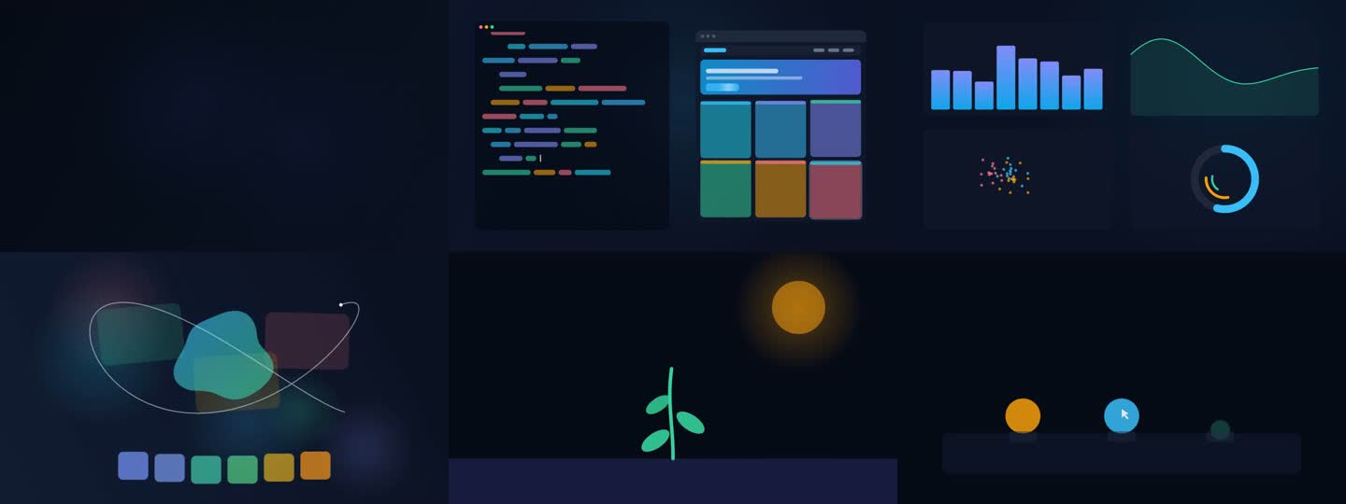
Figure 2: The six on-device, text-free calibration clips (generated, license-free).

6.4 Engagement Scoring
Every five seconds the pipeline builds a 'tick' and computes an engagement score. The score is a weighted mean of the available signals, with the weights renormalised when a signal is missing, then smoothed with an exponential moving average so the displayed value is stable rather than jittery:
Signal | Weight | Source
Blink rate | 0.45 | EAR blink detection mapped onto the learner's personal zones
Facial emotion | 0.35 | Seven-class expression network, baseline-subtracted and grouped
Learner feedback | 0.20 | Quick thumbs up/down and 'still with us?' prompts

Blink rate maps onto five attention zones (hyperfocused, attentive, neutral, fatigued, sleepy). Expressions are baseline-subtracted against the neutral-clip reading and grouped into learning-relevant cues (engaged, confused, frustrated, bored, neutral). When the face is lost and there is no fresh feedback, no score is produced rather than a misleading one.

6.5 Adaptive Curation
A deterministic, priority-ordered state machine decides whether to act on the engagement trend. In strict priority it may: suggest a short break (sustained fatigue/sleepiness), replay a section (confusion), switch the lesson variant (persistent low engagement), slow down, or speed up. Warm-up and cooldown gates prevent it from firing too early or too often, and consecutive-tick counters make it robust to momentary noise. Every suggestion is shown with a short, honest reason and is accepted or dismissed by the learner; a 'take a short break?' prompt, for instance, pauses the lesson and the scoring clock and offers a calm countdown, 'keep going', or 'remind me later'.

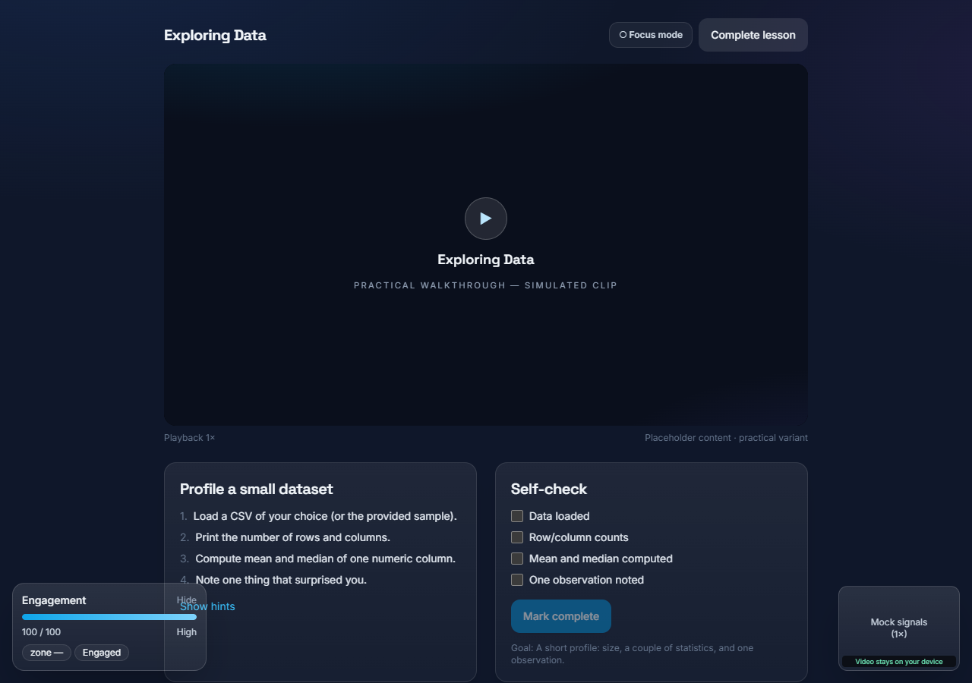
Figure 3: Lesson player with the live engagement HUD and a feedback prompt.

6.6 Learning Style and Recommendations
Engagement per lesson variant is accumulated (the calibration probe weighted more heavily than ordinary lessons) to detect whether a learner engages more with visual or hands-on presentation; the preferred variant is then served, with a small exploration rate to keep refining. Course recommendations combine stated interest, learning-style match and prior history, each shown with a plain-language reason.

6.7 Technology Stack and Deployment
Layer | Technologies
Front end | React 18, Vite, Tailwind CSS, GSAP/Lenis (motion), MediaPipe FaceMesh, face-api.js
Back end | Node.js, Express, better-sqlite3 (SQLite), JSON Web Tokens, Zod validation
Shared logic | Framework-free ES modules with unit tests (one source of truth for all formulas)
Testing | Vitest, Supertest, Playwright (automated browser checks), a dedicated privacy test
Deployment | Front end on Vercel (static build + CDN), back end on Render; auto-deploy on push

The application is deployed and publicly reachable (front end on Vercel, API on Render), communicating over HTTPS with a strict cross-origin policy; the back end only accepts the exact front-end origin.

7. MARKET VALUE ANALYSIS
The global e-learning and EdTech market is large and growing, driven by online degrees, corporate up-skilling and self-paced platforms. A recurring weakness across these products is engagement: learners drop off, and platforms have little real-time insight into why. Attention- and emotion-aware learning that is also privacy-preserving addresses a clear and widening need.
Segment | Value proposition for EduNext
Individual learners / self-study | Studies become adaptive and less wasteful; breaks and replays are suggested when actually needed.
Schools & universities | Engagement insight without surveillance - no video leaves the device, suitable for minors.
E-learning platforms (B2B) | An embeddable, privacy-first engagement layer that differentiates a course product.
Corporate training | Better completion and retention for compliance and up-skilling content.

Because sensing is on-device and needs only a webcam, the marginal cost per user is low and there is no data-protection overhead of storing video. Plausible models include a freemium consumer tier, per-seat licensing for institutions, and an API/SDK for platforms. The honest, non-punitive framing is itself a market advantage as scrutiny of ed-tech surveillance grows.

8. UNIQUE SELLING POINT
• Privacy-first by construction - all attention and emotion sensing happens in the browser; only derived numbers are stored, and this is enforced by an automated test. This is the core differentiator from cloud/proctoring approaches.
• Personalised, not averaged - a short calibration tunes attention zones to each learner, so the system measures 'you', not a generic threshold.
• Helpful, not punitive - the platform adapts to support the learner (breaks, replays, pace, format) with transparent reasons, rather than policing them.
• No special hardware - a standard webcam is sufficient; nothing to buy or install beyond a modern browser.
• Honest and transparent - outputs are consistently framed as estimates, with a clearly labelled scripted demonstration mode for presentations.

9. RESULTS AND DISCUSSION
A complete, working prototype was implemented and deployed. The end-to-end flow - account creation, on-device calibration, lesson playback with a live engagement HUD, adaptive suggestions, a post-lesson summary, and longitudinal insights - functions correctly, and the underlying engagement and curation logic is covered by an automated test suite.
The adaptive pipeline was validated in a scripted demonstration mode that drives the real engagement and curation logic from a simulated signal stream (so the behaviour is genuine, only the input is simulated). In this mode the engagement estimate responds as designed - rising during 'engaged' phases and falling through 'drifting', 'confused' and 'fatigued' phases - and the curation engine issues the corresponding suggestions (for example, proposing a break after sustained fatigue).

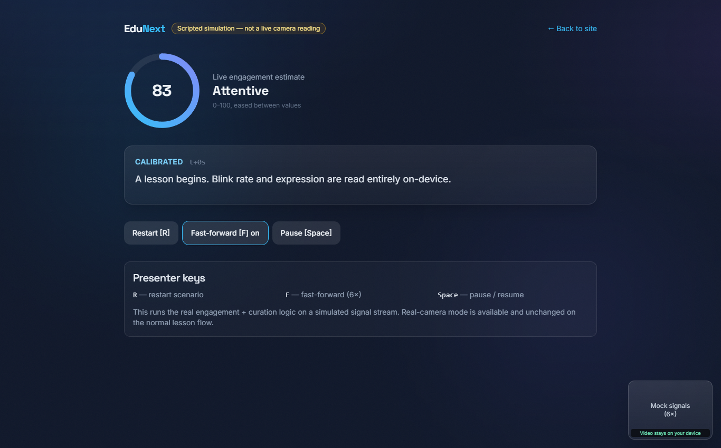
Figure 4: Scripted demonstration mode showing the live engagement score ring and narrated adaptive state.

After a lesson, the learner receives a summary with average engagement, valid (face-visible) time, the served variant, an engagement-over-time chart with markers for each adaptive action, and distributions of attention zones and emotions. An insights page aggregates engagement across sessions and by lesson variant.

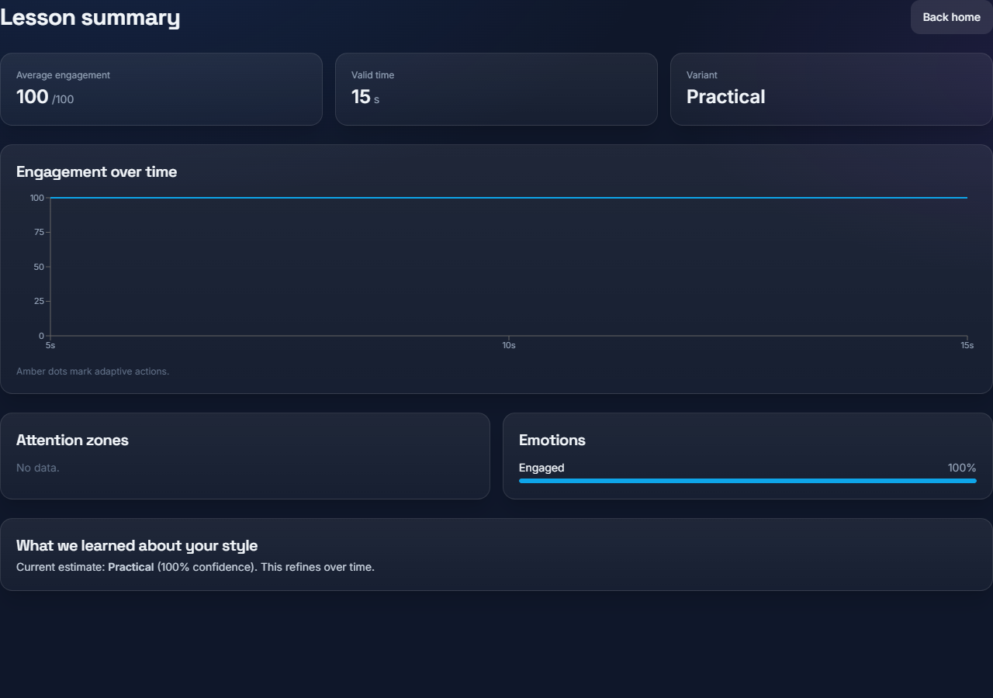
Figure 5: Post-lesson summary - average engagement, engagement-over-time chart, and attention/emotion distributions.
Key outcomes:
Aspect | Result
Functional prototype | Complete flow (register -> calibrate -> learn -> adapt -> summary -> insights) working and deployed.
Personalisation | Calibration produces individualised blink zones, with a clearly flagged fallback to defaults.
Adaptivity | Engagement estimate and curation actions respond correctly to changing signals in validation.
Privacy | No image/video data leaves the browser; enforced by an automated test on the upload schema.
Performance | Production build runs smoothly; the tracker is active only on lessons/onboarding to keep other pages light.
Deployment | Publicly accessible front end (Vercel) and API (Render) with auto-deploy.

Discussion and limitations:
• Engagement is an estimate, not a measurement. Blink rate is affected by lighting, screens, dry eyes and caffeine, and facial expression is a heuristic for inner state; the platform states this explicitly.
• Calibration 'interest' clips are placeholders and only a rough proxy for genuine interest, so the engaged-vs-neutral separation is weaker than it would be with real, personally-relevant content.
• A proper user study (accuracy of the engagement estimate against ground truth, and learning-outcome impact) is future work; the current results demonstrate feasibility and correct system behaviour rather than validated pedagogical gains.
• The free deployment tier sleeps when idle, so the first request after inactivity is slow (handled gracefully); a paid tier would remove this.
10. REFERENCES
1. Nakano, T., et al. Blink-related momentary activation and synchronisation of eye-blinks with attentional demands.
2. Ranti, C., et al. Blink rate as an index of cognitive load and attentional engagement.
3. Maffei, A., & Angrilli, A. Spontaneous eye blink rate as a marker of emotional and attentional state.
4. Ekman, P., & Friesen, W. V. Constants across cultures in the face and emotion; basic facial expressions of emotion.
5. Csikszentmihalyi, M. Flow: The Psychology of Optimal Experience.
6. Google MediaPipe - Face Mesh (real-time facial landmark detection). https://mediapipe.dev
7. face-api.js - JavaScript face detection and expression recognition in the browser.
8. Soukupova, T., & Cech, J. Real-Time Eye Blink Detection using the Eye Aspect Ratio (EAR).
9. React (https://react.dev), Vite (https://vitejs.dev), Express (https://expressjs.com) and SQLite (better-sqlite3) - project implementation frameworks.
Project (live deployment): https://edunext-learn.vercel.app

